Brandon Crenshaw
CS3358 : Data Structures
12- Apr-26

Tree Traversal for Parenthesized Math Expressions

Code
tree.h
/* *************************************************
* Name: Brandon Crenshaw
* Assignment: #3 - Tree Traversal for Parenthesized Math Expressions
* Purpose: To reinforce and demonstrate a sufficient understanding of
* of the tree ADT.
************************************************* */

#define INITIAL_HT -1

#ifndef TREENODE_H
#define TREENODE_H

template <typename T>
class TreeNode {
public:
bool isRoot;
bool isExternal;

TreeNode<T> * parent;
TreeNode<T> * left;
TreeNode<T> * right;
T data;

//Constructor
TreeNode<T>() : parent(nullptr),left(nullptr),right(nullptr) {}
};
#endif // TREENODE_H ---------------------------------------

#ifndef TREE_ADT_H
#define TREE_ADT_H

template <typename T>
class Tree : public TreeNode<T> {
private:
int node_cnt;
int max_depth;

void deleteTree(){
while(node_cnt > 0) remove(treeRoot, treeRoot->data);
}

public:
// CONSTRUCTORS and DESTRUCTOR ----------------------------------------
TreeNode<T> * treeRoot;
Tree() : node_cnt(0), max_depth(INITIAL_HT),treeRoot(nullptr) { }
~Tree() { deleteTree(); }

// ACESSORS -----------------------------------------------------------
T root() const {
if(treeRoot != nullptr) return treeRoot->data;
return T();
}

int height() const { return max_depth; }

int size() const { return node_cnt; }

bool empty() const { return node_cnt == 0; }

TreeNode<T> * search(TreeNode<T> * start, T element) const {
TreeNode<T> * currNode = start;
while (currNode != nullptr){
if ( element == currNode->data ) {
return currNode;
} else if( element < currNode->data ) {
currNode = currNode->left;
} else {
currNode = currNode->right;
} // end of left-right conditionals
} //end of while loop
return nullptr;
}

// MUTATORS -----------------------------------------------------------

bool addLeft(TreeNode<T> * curNode, T element) { // element will have to be updated to use keys
bool isAdded = false;
if(curNode->left == nullptr) {
TreeNode<T> * inNode = new TreeNode<T>; //create new node and update its info
inNode->data = element;
inNode->parent = curNode;
curNode->left = inNode;
isAdded = true;
node_cnt++;
}
return isAdded;
}

bool addRight(TreeNode<T> * curNode, T element) { // element will have to be updated to use keys
bool isAdded = false;
if(curNode->left == nullptr) {
TreeNode<T> * inNode = new TreeNode<T>; //create new node and update its info
inNode->data = element;
inNode->parent = curNode;
curNode->right = inNode;
isAdded = true;
node_cnt++;
}
return isAdded;
}

bool remove(TreeNode<T> * start, T element) {
/* removes nodes from the tree */
TreeNode<T> * currNode = search(start, element);
TreeNode<T> * promotedNode = nullptr;

if (currNode == nullptr) {
return false;
}
// FOR NODES with NO CHILDREN
if(currNode->left == nullptr && currNode->right == nullptr) {
if ( currNode->parent == nullptr) { // node is root node
treeRoot = nullptr;
delete currNode;
currNode = nullptr;
} else if (currNode->parent->left == currNode) { // node is external left child
currNode->parent->left = nullptr;
delete currNode;
currNode = nullptr;
} else { // node is external right child
currNode->parent->right = nullptr;
delete currNode;
currNode = nullptr;
} // closes "root-left-right" conditional
} // closes "no children" block
// For NODES with ONE CHILD
else if (currNode->right == nullptr) { // node has left child only
if( currNode->parent == nullptr ) {
treeRoot = currNode->left;
delete currNode;
currNode = nullptr;
} else if ( currNode->parent->left == currNode ) {
currNode->parent->left = currNode->left;
delete currNode;
currNode = nullptr;
} else {
currNode->parent->right = currNode->left;
delete currNode;
currNode = nullptr;
}
}
else if (currNode->left == nullptr) { // node has right child only
if( currNode->parent == nullptr ) {
treeRoot = currNode->right;
} else if ( currNode->parent->left == currNode ) {
currNode->parent->left = currNode->right;
} else {
currNode->parent->right = currNode->right;
}
}
// For NODES with TWO CHILDREN
else {
promotedNode = currNode->right; // select the immediate right child
while (promotedNode->left != nullptr) { // then selects thr left-most leaf
promotedNode = promotedNode->left;
}
T promotedData = promotedNode->data; // copies data (not key); So copy both when updated.
remove(treeRoot,promotedNode->data); // removes the node with 0 or 1 child
node_cnt++;
currNode->data = promotedData;
}
node_cnt--;
return true;
}

};

#endif // TREE_ADT_H

expTree.h
/* *************************************************
* Name: Brandon Crenshaw
* Assignment: #3 - Tree Traversal for Parenthesized Math Expressions
* Purpose: To reinforce and demonstrate a sufficient understanding of
* of the tree ADT.
************************************************* */

#include <iostream>
#include <stack>
#include <string>
#include <cctype> // for isalnum()
#include "tree.h"

#ifndef EXP_TREE_H
#define EXP_TREE_H

template <typename T>
class ExpTree : public Tree<T> {
public:
// MEMBER VARIABLES ------------------------------------
std::stack<TreeNode<T>*> operands;
std::stack<char> operators;

// CONSTRUCTOR & DECONSTRUCTOR -------------------------
ExpTree() { } // Nothing added. Leans on the tree (base) class
~ExpTree() { } // Nothing added. Leans on the tree (base) class

// METHODS --------------------------------------------
TreeNode<T>* createNode(T val) {
/* Function to create new nodes*/ // Easier b/c unlike BSTs, expression
TreeNode<T>* node = new TreeNode<T>; // trees require alot manipulation (IMHO)
node->data = val;
return node;
}

void storeExpression(const std::string& expr) {
/* Takes the expression string and puts into tree form*/
for (char ch : expr) {
if (isspace(ch) || ch == '(') continue;

if (isalnum(ch)) { // disregards punctionation et al.
operands.push(createNode(ch));
}
else if (ch == '+' || ch == '-' || ch == '*' || ch == '/') {
operators.push(ch); // strictly for operators
}
else if (ch == ')') {
// sub-expressions are built here; with operators as parents
if (operators.empty() || operands.size() < 2) continue;

TreeNode<T>* pNode = createNode(operators.top());
operators.pop();

pNode->right = operands.top();
operands.pop();

pNode->left = operands.top();
operands.pop();

operands.push(pNode);
}
}
if (!operands.empty()) { // Ties it all together
Tree<T>::treeRoot = operands.top(); // designates root as the root of the tree.
}
}

void preorderPrint(TreeNode<T>* node) {
/* prints tree in preorder format */
if (!node) return;
std::cout << node->data << " ";
preorderPrint(node->left);
preorderPrint(node->right);
}

void postorderPrint(TreeNode<T>* node) {
/* prints tree in postorder format */
if (!node) return;
postorderPrint(node->left);
postorderPrint(node->right);
std::cout << node->data << " ";
}
};

#endif

top.cpp
/* *************************************************
* Name: Brandon Crenshaw
* Assignment: #3 - Tree Traversal for Parenthesized Math Expressions
* Purpose: To reinforce and demonstrate a sufficient understanding of
* of the tree ADT.
************************************************* */

#include "expTree.h" // iostream is already included here

int main(void) {
std::string expr = "((A+B)/(C-D))"; // from instructions
std::cout << "Input string: " << expr << std::endl;

ExpTree<char> tree;
tree.storeExpression(expr);

std::cout << "Pre-order: ";
tree.preorderPrint(tree.treeRoot);
std::cout << std::endl;

std::cout << "Post-order: ";
tree.postorderPrint(tree.treeRoot);
std::cout << "\n" << std::endl;

/* * * * * * * * * * * * * * * * * * * * * * * * * * * * * * * * * * * * * * * * * * */
/* Expression take from HW#3 */
std::string expr2 = "(((5+2)*(2-1))/(((2+9)+((7-2)-1))*8))";
// parentheses added after '/' because it wasn't fully parenthesize.

std::cout << "Input string: " << expr2 << std::endl;

ExpTree<char> tree2;
tree2.storeExpression(expr2);

std::cout << "Pre-order: ";
tree2.preorderPrint(tree2.treeRoot);
std::cout << std::endl;

std::cout << "Post-order: ";
tree2.postorderPrint(tree2.treeRoot);
std::cout << "\n" << std::endl;

/* * * * * * * * * * * * * * * * * * * * * * * * * * * * * * * * * * * * * * * * * * */
/* Something I just made up */
std::string expr3 = "(((((((1+2)+3)+4)+5)+6)+7)+8)";
std::cout << "Input string: " << expr3 << std::endl;

ExpTree<char> tree3;
tree3.storeExpression(expr3);

std::cout << "Pre-order: ";
tree3.preorderPrint(tree3.treeRoot);
std::cout << std::endl;

std::cout << "Post-order: ";
tree3.postorderPrint(tree3.treeRoot);
std::cout << "\n" << std::endl;

return 0;
}

Outputs
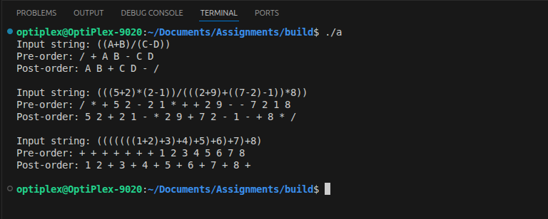

Stack/Queue Conversion
void preOrd(const std::string& expr){
// Much of this is copied from tree stuff but is stored strings instead of trees/nodes
std::stack<std::string> preStack;
std::stack<char> operatorStack;
std::string subexp;

for (char entry : expr) {
if (isspace(entry) || entry == '(') continue;
if (isalnum(entry)) preStack.push(std::string(1, entry)); // string function converts char -> string
else if (entry == '+' || entry == '-' || entry == '*' || entry == '/') operatorStack.push(entry);

else if (entry == ')') {
if (operatorStack.empty() || preStack.size() < 2) continue;

std::string oprtr = std::string(1,operatorStack.top()); // pulling from stacks and building subexpressions
operatorStack.pop();
std::string right = preStack.top();
preStack.pop();
std::string left = preStack.top();
preStack.pop();
subexp = oprtr + " " + left + " " + right + " ";
preStack.push(subexp); // Very [censored] important
}
}
std::cout << subexp << std::endl;
}

void postOrd(const std::string& expr){
/* A repeat of the preorder function*/
std::stack<std::string> postStack;
std::stack<char> operatorStack;
std::string subexp;

for (char entry : expr) {
if (isspace(entry) || entry == '(') continue;
if (isalnum(entry)) postStack.push(std::string(1, entry));
else if (entry == '+' || entry == '-' || entry == '*' || entry == '/') operatorStack.push(entry);

else if (entry == ')') {
if (operatorStack.empty() || postStack.size() < 2) continue;

std::string oprtr = std::string(1,operatorStack.top());
operatorStack.pop();
std::string right = postStack.top();
postStack.pop();
std::string left = postStack.top();
postStack.pop();
subexp = left + " " + right + " " + oprtr; // the order needed to be "post"
postStack.push(subexp);

}
}
std::cout << subexp << std::endl;
}

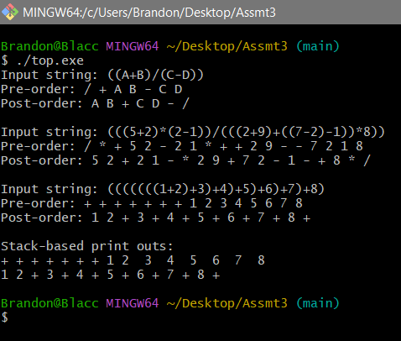

Learning Report
The first thing I had to learn was that an expression tree, although a binary tree, is not a binary search tree. I spent so much time working and figuring to make the underlying tree structure a BST-type structure only to realize that I had wasted my time. Note tht the delete node method still remain even they aren't really needed; it used to de-allocate memory for the destructor.

I also learned that stacks/queues are fundamental to these structures. I could be wrong, but parsing expressions seem to demand them (or some cruder mechanism that implement the same functionality. Much time was dedicated to this task as well.

In general, I learned that I don't really understand trees that well, but more than that I really learned that I need a lot of work in the application of stacks. Understanding the latter is more valuable than the former because believing you understand something you do is more detrimental than simple ignorance. Thus I will need to dedicate a lot of real estate on my exam notes to both of these topics.

